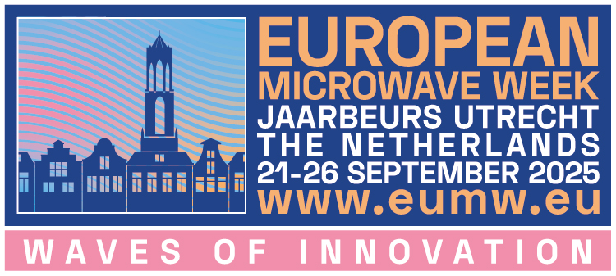
2025 European Microwave Week: Workshop/Short Course Proposal

Note: the deadline for submission of the proposals is 28th January 2025.
Please submit proposals to: workshop.chair.eumw2025@eumwa.org

Organizer(s) information:
 | First name | Family name | Affiliation | e-mail | Telephone
Organizer 1
Organizer 2 (if present)
Organizer 3 (if present)

Event information:
Please choose by marking the desired options.
Event type | Workshop (WS)
Event type | Short Course (SC)
Duration | Half day
Duration | Full day
Conference | EuMC
Conference | EuMIC
Conference | EuRAD

Workshop/Short Course title
Topic
Expected attendance
Workshop abstract (max 250 words)

Important information:
- Accepted workshops/short courses will be scheduled for one of the workshop days of the EuMW 2024 mainly on Sunday, Monday and Friday. The assigned date and time slot cannot be disputed and the organizers are expected to inform the speakers accordingly.
- It is the responsibility of the organizers to upload the presentation slides, including the presentation slides of ALL speakers, before the deadline specified in the conference website (1 color slide per A4 page in pdf format).
- Workshop fee waivers will be granted to the workshop organizers (maximum two) and workshop speakers (one per presentation) upon reception of the final presentation slides. The maximum number of speakers allowed for a half day workshops/short courses is four, and for a full day workshops/short courses is eight. The fee waivers will not be granted if the final presentation slides are not uploaded before the deadline.
- Please note that the fee waiver applies ONLY to the specific workshop and NOT to other events taking place during the week. Therefore, workshop speakers and workshop organizers must register and pay the fees for the other events they wish to attend (EuMC, EuMIC, EuRAD, DSS forum, other WS/SC etc.).

I have read and understood the above important information and shared this information with all the Speakers who also understood (Yes/No):

Please complete the rest of the form only if your answer to the above question is “Yes”.

Speakers information:
Add the information of all the speakers. More lines can be added if needed.
 | Confirmed? (Yes/no) | First name | Family name | Affiliation | e-mail | Presentation Title | Summary  (2-3 sentences)
Speaker
1
Speaker
2
Speaker
3
Speaker
4
Speaker
5
Speaker
6
Speaker
7
Speaker
8

Special requests:
Please indicate any additional information or special requests here.

Workshops are intended to address state-of-the-art topics with an expert audience, whereas short courses have an educational purpose and are directed also to non-expert audience members.
In case of a joint workshop/short course, please cross all applicable conferences.

